**Database Systems Project 1**

**Group members:**

**Dhruv Patel: 1001748952**

**Nahal Maymandi: 1001785613**

**Sudharsan Rajam: 1001874246**

**Table Creation**

**1) Employee Table**

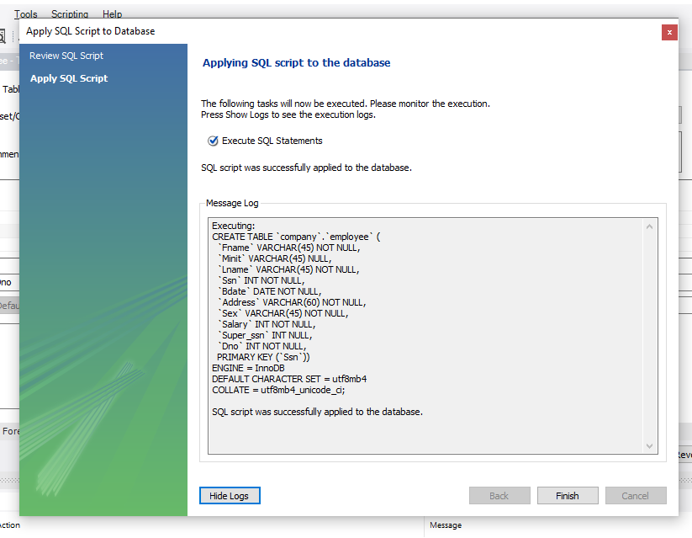

**Data Imported in Employee table**

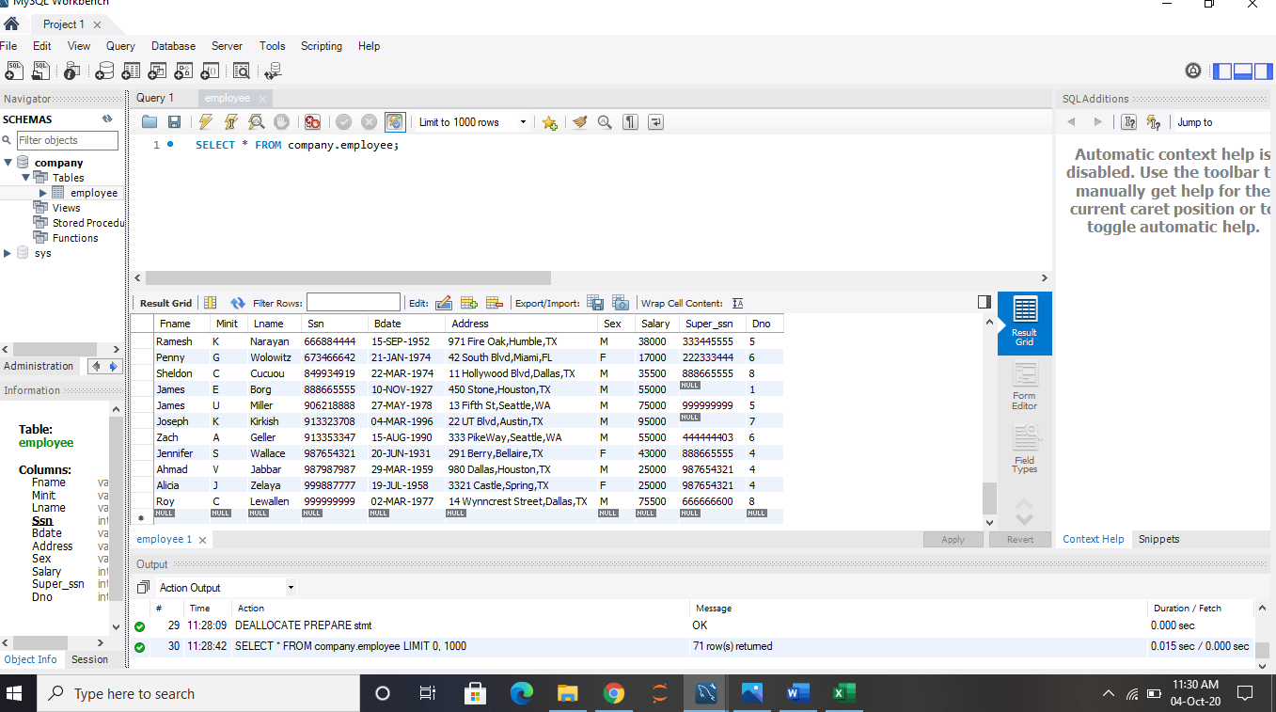

**2) Department table**

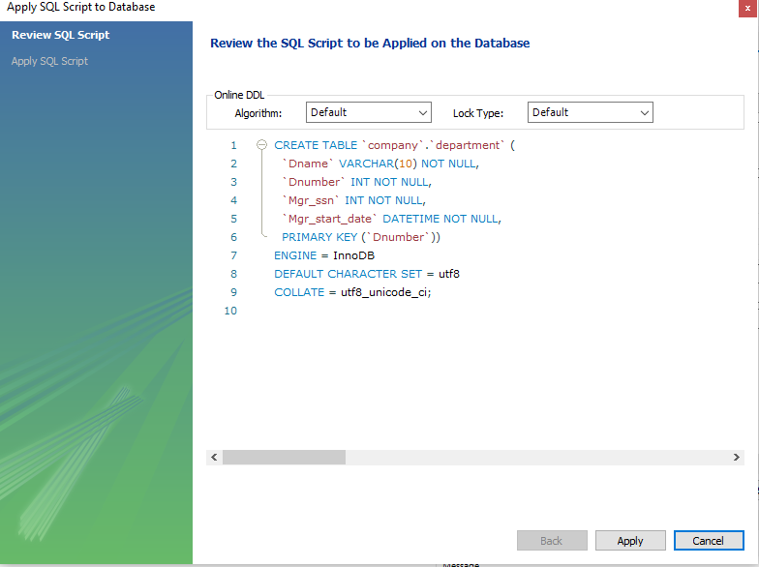

**Data Imported in Department Table:**

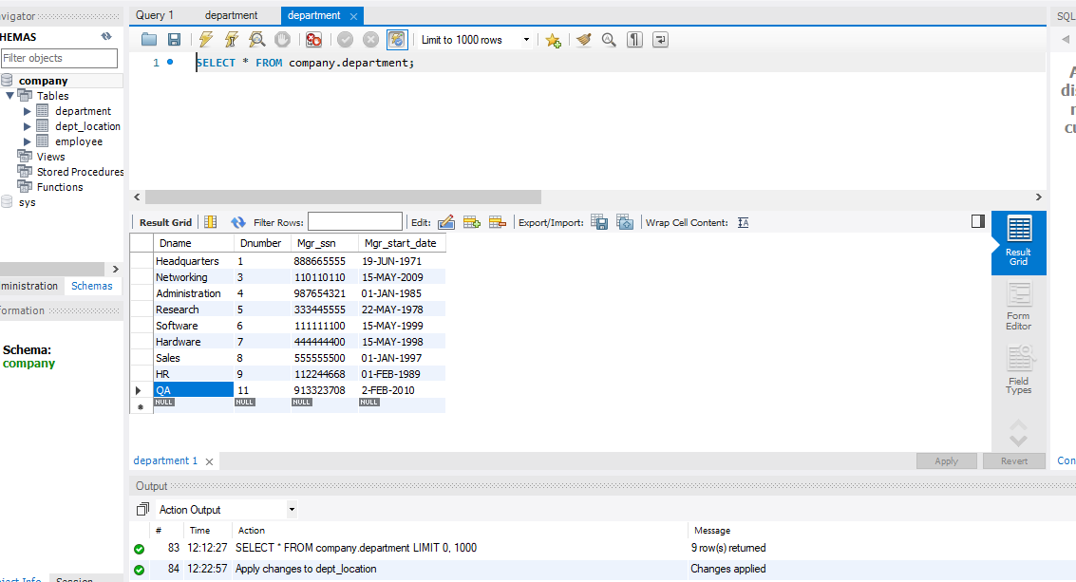

**3) Department Location**

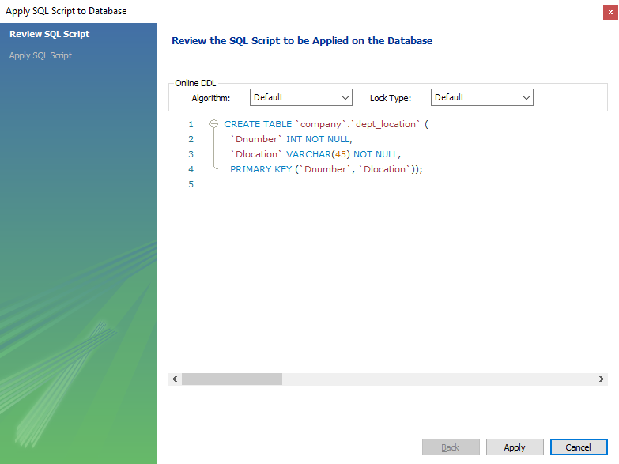

**Data Imported in Department Location**



**4) Works_on Table**

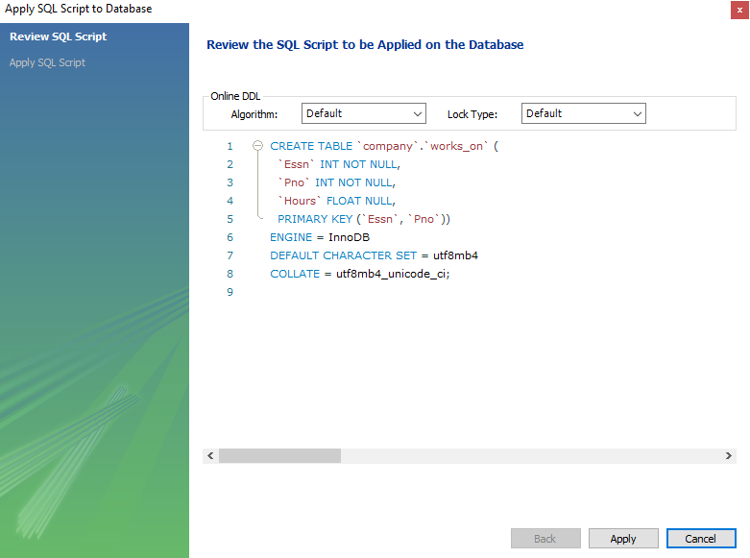

**Data Imported in works on Table**

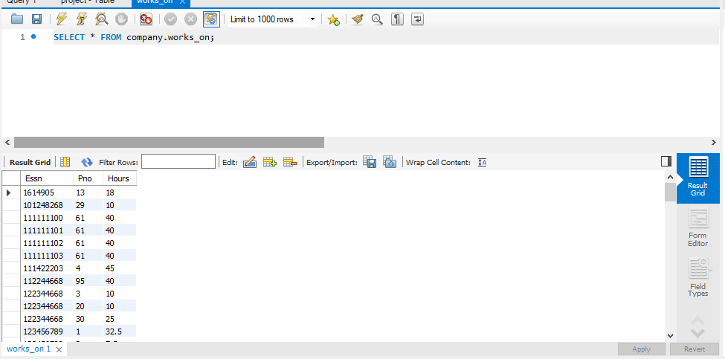

**5) Project table:**

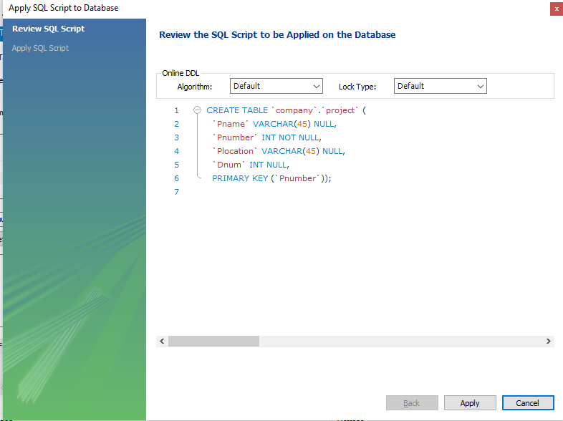

**Data Imported in Project Table:**

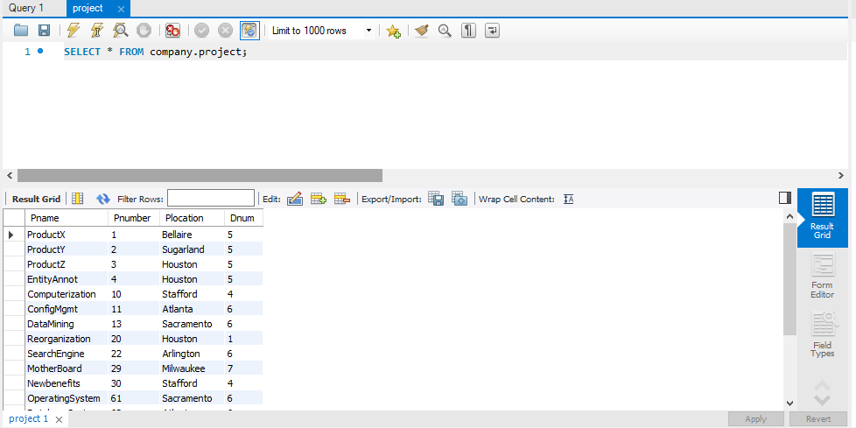

**SQL QUERIES PERFORMED ON THE DATABASE**

1) Enter a department name and retrieve all the names and salaries of all employees who work in that department.

**Answer:** **SELECT** Fname,Minit,Lname,Salary **FROM** employee **inner JOIN** department **on** employee.Dno=department.Dnumber **where** department.Dname='Research'

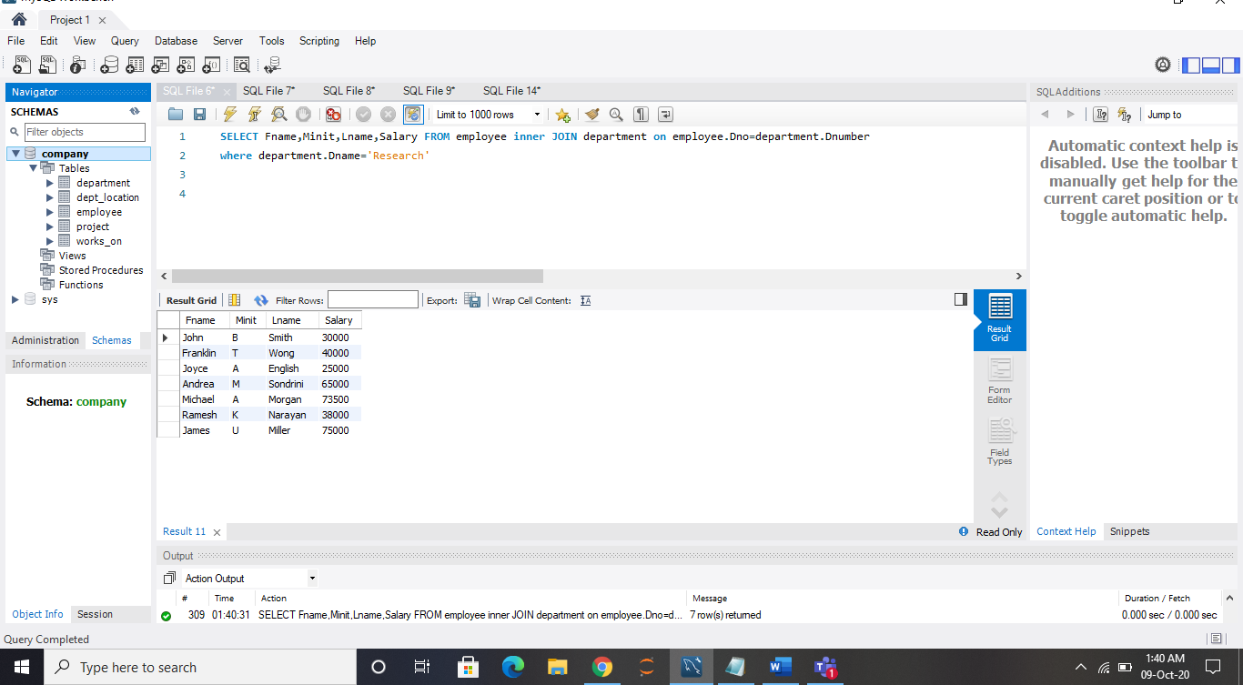

2) Enter an employee last name and first name and retrieve a list of projects names/hours per week that the employee works on.

**Answer: select** Pname,Hours **from** employee **inner join** project **on** project.Dnum=employee.Dno **inner join** works_on

**on** works_on.Essn=employee.Ssn **where** employee.Fname='John' **and** employee.Lname='Smith'

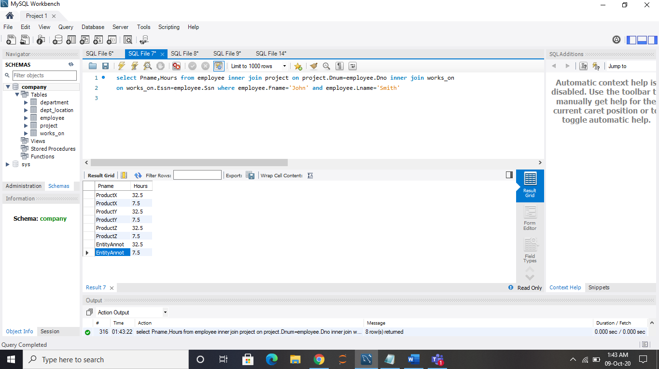

3) Enter a department name and retrieve the total of all employee salaries who work in the department.

**Answer : select** sum(employee.Salary) **from** employee **inner join** department **on** employee.Dno=department.Dnumber **where** department.Dname='Research'

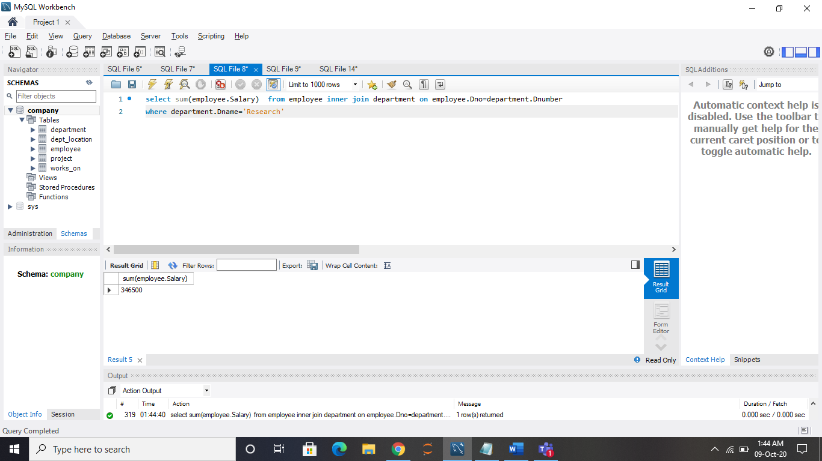

4) For each department, retrieve the department name and the number (count) of employees who work in that department. Order the result by number of employees in descending order.

**Answer : SELECT** Dname **AS** 'Department Name',

**COUNT(*) AS** 'No of Employees'

**FROM** department

**INNER JOIN** employee

**ON** employee.Dno = department.Dnumber

**GROUP BY** department.Dname, department.Dnumber

**ORDER BY count(*)** **desc;**

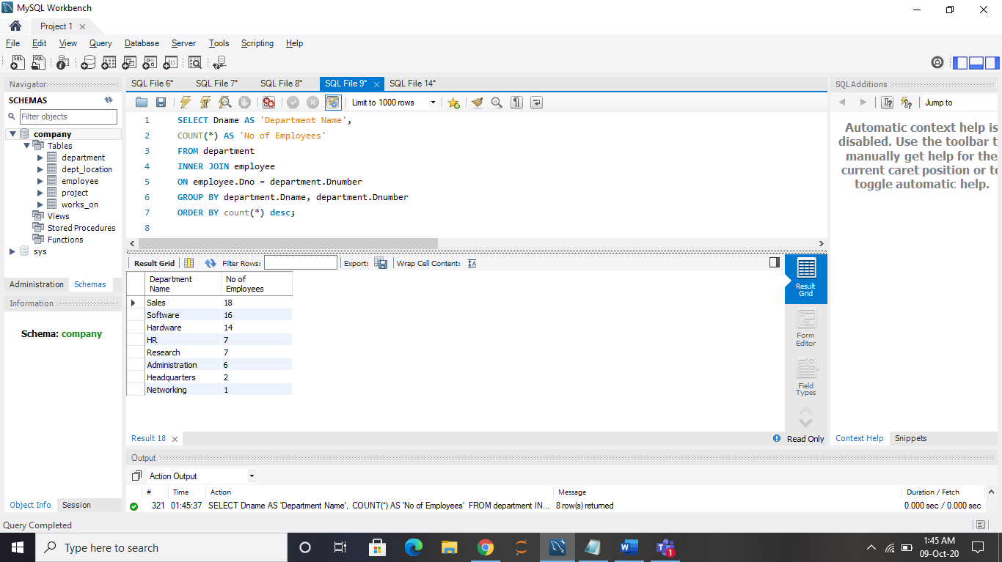

5) For each employee who is a supervisor, retrieve the employee first and last name and the number (count) of employees that are supervised. Order the result in descending order.

**Answer : SELECT** **concat**(e.Fname,' ' ,e.Lname) **AS** Supervisor_name, m.Employees_supervised **FROM** EMPLOYEE e

**JOIN (SELECT** Super_ssn, **COUNT**(Super_ssn) **as** Employees_supervised **FROM** Employee **GROUP BY** Super_ssn) m **ON** e.Ssn = m.Super_ssn **ORDER BY** Employees_supervised desc;

